
Lesson 14: Raising the Stakes
Unity
VIDEO GAME CREATION
This week: later waves get genuinely harder - more enemies, moving faster - using the exact wave variable you've had since Lesson 11.
Open your own [YourName]Game project from Lesson 13 - don't start a new one.
Tip: no new assets this week - difficulty scaling reuses your exact existing enemy sprites and spawn logic.

Setup
- Open your [YourName]Game project from Lesson 13.
- No new fields needed for Level 1 - Level 2 will use Enemy.cs's existing speed field (from Lesson 7).

Level 1 - Minimal (MVP)
Each wave spawns one more enemy than the last (5, 6, 7). Speed stays the same for now - that's Level 2.
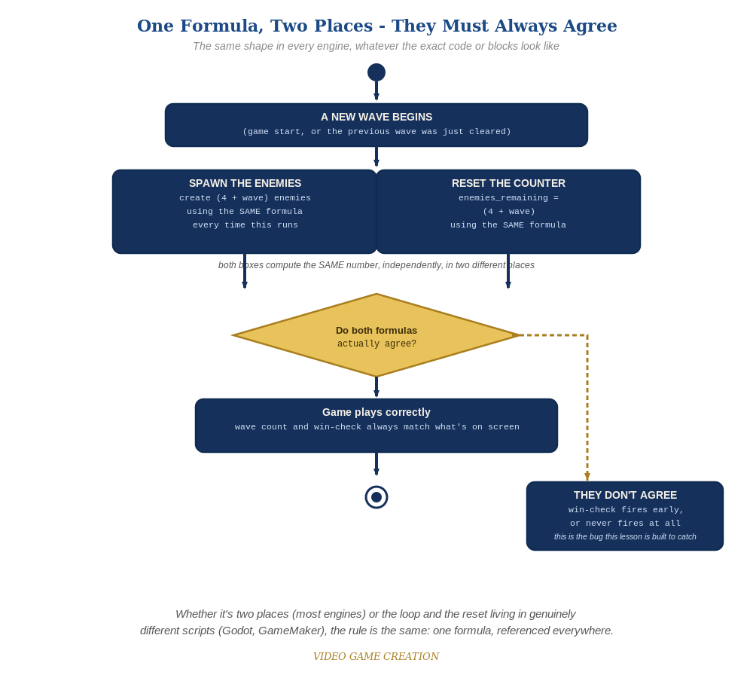
Whether the spawn loop and the reset live in two places or two genuinely different scripts, the rule is the same: one formula, referenced everywhere.
- In EnemySpawner.cs's SpawnEnemies(), change the fixed loop count of 5 into (4 + GameManager.wave) (code below) - wave 1 spawns 5, wave 2 spawns 6, wave 3 spawns 7.
- Wherever enemiesRemaining gets reset to 5 for a new wave, change that to 4 + wave too - these two places must always agree.
- Press Play and play through a full round - wave 2 should visibly spawn one more enemy than wave 1, and wave 3 one more than that.
Highlighted lines are new this week; everything else is code you already have.
// EnemySpawner.cs:
public void SpawnEnemies() {
int count = 4 + GameManager.wave;
for (int i = 0; i < count; i++) {
GameObject e = Instantiate(enemyPrefab);
// ...existing per-enemy positioning...
}
GameManager.enemiesRemaining = count;
}

Alternate Path: Visual Scripting
The same wave-dependent formulas work as Script Graph math nodes instead of C# expressions.
- On your spawn-loop graph, replace the fixed loop count of 5 with an Add node combining 4 and the current Wave value.
- On each spawned enemy, add a "Set Member" node targeting the enemy's own EnemyMover script and its speed field, fed by an Add node combining 1.5 and (Wave - 1) times 0.5 - Set Member targets a real, type-checked field on the component (pick it from a list), so prefer it over the generic Variables > Set Variable node, which stores under a loose string key instead.

Level 2 - Complete (Alpha/Beta)
Enemy speed ALSO increases each wave, on top of the growing count. Restarting correctly returns everything to wave 1's original values.
- In SpawnEnemies(), right after instantiating each enemy, set its speed based on the wave: e.GetComponent<Enemy>().speed = 1.5f + (GameManager.wave - 1) * 0.5f.
- Confirm Enemy.cs's own speed field (from Lesson 7) is still what its Update() movement actually reads - no changes needed there.
- Restart mid-game and confirm both count and speed return correctly to wave 1's values.
- Play a full round and confirm wave 3 is noticeably busier and faster than wave 1, but still fair.

Level 3 - Refined - Choose ONE Stretch Feature
Pick exactly one of the five ideas below. These are intentionally open-ended - a good-faith attempt at the general idea is a complete Level 3 finish, not a fully polished feature.
- Destructible shields/barriers: a few simple blocks placed between the player and the enemies that disappear (or shrink) after absorbing a hit or two - reuses your existing collision-detection and hit-reaction patterns from Lessons 4 and 13, just on a new kind of object.
- A power-up: an item that occasionally drops or spawns, which the player collects to temporarily change how shooting works (faster fire rate, multiple bullets at once, or a brief shield) - reuses your existing timer/cooldown pattern from Lesson 3.
- A bonus enemy: a rare, faster-moving, or oddly-patterned enemy worth extra points, spawned occasionally alongside a normal wave - reuses this week's own speed/count scaling ideas, just for one special case instead of the whole wave.
- Formation-marching movement: instead of each enemy independently drifting down (this course's approach since Lesson 4), have the whole wave move together as a group and occasionally step sideways - a genuinely different movement pattern, inspired by classic arcade shooters.
- A title screen and/or game-over screen: a proper opening screen (press a key to start) and/or a dedicated game-over screen with a final score, instead of just text overlaid on the gameplay - reuses your existing game_active flag and UI tools from Lessons 9-10. Unity's UI Canvas system (already used for your HUD since Lesson 9) is a natural fit for a title/game-over screen.

If Something's Wrong
- Every wave still spawns exactly 5: confirm the loop actually uses (4 + GameManager.wave) and not a leftover literal 5.
- The win message fires early or never: confirm enemiesRemaining is reset using the SAME formula everywhere it's set.
- Speed doesn't change between waves: confirm each new enemy's speed field is being set INSIDE SpawnEnemies(), not left at the prefab's default forever.

Want More?
Student Resource List > Unity section, or learn.unity.com

